 | SAFE SYSTEM of WORK  Manual Handling |  | SSoW No.32
 |  |  | Date: January2024
Basic:

- Think before lifting! Is it heavy? Can it be made lighter by dividing the load up? Can you manage it alone?
- Use the strong muscles of your legs, not the complex and vulnerable ones in your back.
- Make sure you have a firm grip of the load and that you can sustain the grip for the duration of the lift. Wear industrial gloves to improve grip and to protect hands from sharp edges.
- Make sure you know where you are going to put the load and that the way is clear of obstacles and not slippery. The load must not impede your forward view.

- If in doubt, get help! There is nothing macho about a slipped disc

DO |  | DO NOT
- Use trolleys to move loads whenever possible  - Ensure any spillages are cleaned up immediately and safety signs are put out  - Use lifts to move loads between floors where possible  - Use gloves when the load has sharp edges  - Check your route before moving a load  - Break the load down into manageable units if possible  - Position your feet correctly by placing them apart  - Use your leg muscles to lift the load  - Ensure a full palm grip on the load  - Keep your arms and the load close to your body  - Ensure you can see over the load  - If the route is long or the task is repetitive, take a break in the middle |  | - Attempt any lifting / carrying if you are not feeling well  - Do heavy lifting / carrying if you are pregnant  - Try to lift big objects on your own - get help  - Bend your back to lift a load  - Exceed your limitations
Specific Training Requirements.
- Manual Handling TBT
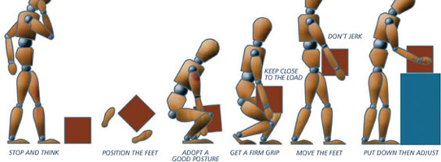
Personal Protective Equipment needed
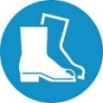 | Safety footwear | 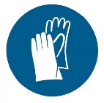 | Safety gloves (if the load has sharp edges

